6A^{th} Grade: Unit 10, Lesson 1

- A data set is shown. What is the mode of the data set?
{89, 95, 93, 93, 89, 92, 93}
93

- Is it possible for a data set to have no mode? Explain.

Yes, it is possible to have no mode if the data set does not have a value that occurs the most.

- A box plot is shown. What is the interquartile range?
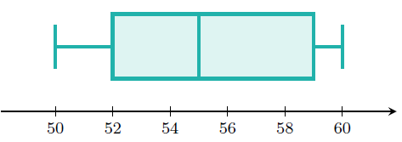

7

